**EXP NO 23**

To design DFA of odd number of a’s in automata.

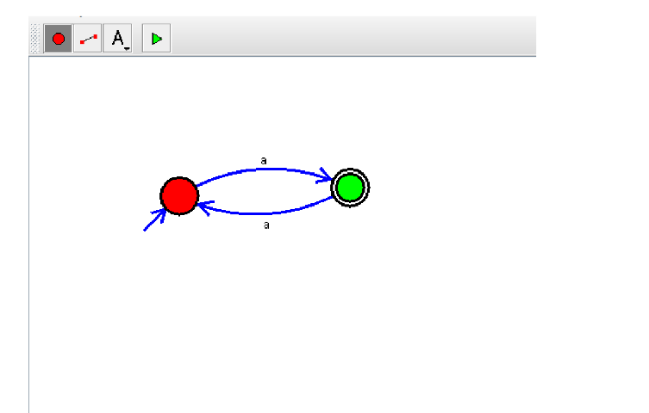

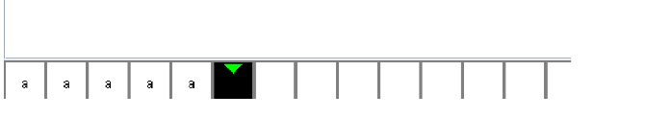

**Result:** Thus designing DFA of odd number of a’s is done and verified by giving sample inputs.